2025 BALLOONS
OVER WADSWORTH OPERATIONS MANUAL
HOSTED BY:

Inspire Aviation


This manual is part of the application process for issuance of a FAA Certificate of Waiver or Authorization (FAA Form 7711-2), with attachments and special provisions for a manned free balloon competition on August 8th-10th, 2025. This Balloon Competition handbook is for Balloons Over Wadsworth, Wadsworth Ohio. The competition is under the direction of the Balloon Federation of America.

Table of Contents

Event Staff .......................................................................................................................................3 Emergency Numbers .......................................................................................................................3
Duties of Personnel .........................................................................................................................4
Registration and Airworthiness Determination ..............................................................................4
Pilot and Event Flight Crew members ............................................................................................4
Pilot Crew Briefing Procedures ......................................................................................................4
Event Documentation ......................................................................................................................5
Clear Areas .....................................................................................................................................5
Crowd Control Requirements .........................................................................................................5
Landowner Relations/Notification ..................................................................................................6
Area of Operations ..........................................................................................................................6
Types of Operations ........................................................................................................................6
Altitudes ......................................................................................................................................... 6
Weather Requirements ................................................................................................................... 7
Communications Requirements / RECALL .................................................................................... 7 Air Traffic Coordination ................................................................................................................ 7
Balloons Over Wadsworth Festival
Map................................................................................................................................................. 8
Detroit Sectional .....................…..............................................................................................…...9
SCHEDULE –2025........................................................................................................................10
Acknowledgement of Responsibility and Briefing.........................................................................11
Release of all Claims.....................................................................................................................12
2025 Pilots Roster.........................................................................................................................13

EVENT STAFF AND OTHER IMPORTANT CONTACT INFORMATION

Balloon Event Staff
Chris Smart  Shannon Rote  James Mitchell  Sean Askren  Patty Cramer  Steve Mitchell  Ryan Duff  Mike Bowser  Tom Strong  Matt Hiscock  Dan Chafin | Balloon Director /Asst Safety Officer  Landowner Relations  Asst Director/Competition Director  Safety Officer  Chief Scoring Officer  Weather Officer  Assistant Weather Officer  Airplane/Helicopter Director  Balloons over Wadsworth Chair  Public Service Director  Public Safety Director | (260) 224-0251  (330) 322-7679  (269) 579-0686  (513) 594-9070  (740) 502-0677  (269) 579-0751  (505) 269-3071  (330) 807-4065  (330) 464-5665  (330) 335 2705  (330) 335 2705
 | Emergency Numbers
WDP Dispatch  Terry Grice  Daniel Chafin  Robert Lindner | Emergency/non-emergency 911/330.334.1511  Medina County Sheriff 330.764.8631  Wadsworth Police Chief 330.334.1511  Wadsworth Fire Chief 330.335.2850
City of Wadsworth Electrical Department 330.335.2833
Wadsworth Towing Vehicle Towing Company 330.336.9250

More Extensive Details are available in the 2025 Emergency Action Plan for
this Hot Air Balloon Event

SECTION I – PURPOSE

This manual is submitted as a part of an application for a waiver of Title 14 of the Code of federal Regulations (14 CFR) part 91, §§ 91.119(b) and (c), by Balloons Over Wadsworth. Specifically, the waiver will allow officially registered balloons to operate at an altitude of no less than 500 feet above the highest obstacle within 500 feet horizontal radius of a balloon in route to the target within a 10 nautical mile radius of the designated launch field or goal. It will also allow for officially registered balloons to operate at 75 feet AGL above spectators and to set goals and/or targets at a minimum distance of 200 feet from physical barriers provided for spectator control. The waiver will also allow officially registered balloons to descend to the surface over open water or sparsely populated areas including declared targets, but no closer than 200 feet from any person, vessel, vehicle, or structure. No waiver is requested nor is waiver required by 14 CFR for any mass ascensions or pilot choice launches.

SECTION II - RESPONSIBILITIES AND PROCEDURES

Duties of Personnel
Balloon Director - Chris Smart
Assistant Director – James Mitchell
Competition Director - James Mitchell
Safety Officer - Sean Askren
Landowner Relations – Shannon Rote
Chief Scoring Officer - Patty Cramer
Weather Officer - Steve Mitchell
Assistant Weather Officer - Ryan Duff
Airplane/Helicopter Director - Inspire Aviation - Mike Bowser
Balloons over Wadsworth Chair - Tom Strong

Registration and Airworthiness Determination
Balloons flown at the event must have current certificates of registration and airworthiness, or in place of the latter, an equivalent document from the Federal Aviation Administration. Throughout the event, the Safety Officer or his designee(s), and appropriate FAA personnel, will be consulted as necessary. Updates for all pilot records will be reviewed by key Staff upon Registration of all Pilots and be available for FAA review.

Pilot and Event Flight Crew members
Each pilot must hold the appropriate pilot certificate (Private or Commercial) with Lighter-Than-Air Category and Free Class Rating and have a minimum of 50 hours as pilot in command (PIC). Student pilots are prohibited from flying as PIC during this event. Each pilot must show evidence of current Flight review (14 CFR part 61, §61.56) and must show evidence of currency per §61.57. Event flight crew members carried on board a balloon during the event must have been briefed by the pilot in command (PIC) of the balloon and must attend the pilot briefing for that flight. Each event flight crew member must sign the waiver form supplied by the PIC. Each event flight crew member must attest that they have attended the applicable pilot briefing(s) and have read and understand the conditions of the waiver. During competition and fiesta flights, the event flight crew members will be kept to a minimum and are limited to a maximum of two per balloon. If the number of event flight crewmembers specified does not exceed the respective balloon flight manual.

Pilot Crew Briefing Procedures
All pilots are required to sign a statement indicating that they have read and understand the provisions of the waiver and the official event operation manual prior to any flight. Before each flight all pilots must attend the flight briefing & will sign in at the briefing.

Letter of Agreement / Statement of Responsibility
Each pilot will sign a letter of agreement and statement acknowledging their responsibilities under the FARs as related to Balloons Over Wadsworth. Copies of all Records will be kept by the Event Organizer.

Event Documentation
All relevant registration files, pilot registration information, task data sheets, etc. will be maintained by the organizer at least 60 days after the event and will be made available to the FAA Monitor upon request. Competition maps and task sheets will also be available at pilot briefings.

SECTION III - GROUND OPERATIONS

Clear Areas
Clear areas are established at each target site. These areas are kept clear of spectators and are frequently fenced. Scoring officials will police target sites to keep unauthorized persons out. In the Minimum Altitude Diagram, this is referred to as the Target Area.” Certain competitive tasks have predetermined goals associated with the intersection of two minor public roads or a public road and a railroad where strict control by event officials must be maintained in the interests of public safety and preservation of results where markers are dropped.

Spectator Areas
The primary competitive spectator area is located at the main launch site (parallel to the taxiway at the Wadsworth Municipal Airport). Physical barriers around the launch site initiate crowd control, and target areas are controlled by scoring officials. Official and balloon recovery vehicles are parked in restricted areas. Traffic is controlled by local police and committee safety personal as required. The use of existing and temporary barriers serves to restrict spectators from the potential low-level flight areas in and around goals/targets. It should be noted that the flight of a balloon occurs at sufficiently slow speeds that people have ample opportunity to move away and stand well clear from approaching balloons as directed by event safety officials. Competitive goals/targets set outside the primary launch field in remote areas attract few, if any, spectators beyond those directly involved in event operations (officials and crew). Scoring and measuring official’s control these areas as determined by conditions and will isolate the area surrounding the goal/target from any unauthorized personnel. Where goals are located on public roads extra caution will be taken by the officials on site to protect themselves, the motoring public, and all bystanders, particularly where markers are dropped and need to be accurately measured before they are moved.

Crowd Control Requirements
Local law enforcement as well as committee security personnel under the direction of the Safety Officer will provide crowd control.

Landowner Relations/Notification
Positive landowner relations are crucial to the continuance of competitive ballooning. There is an ongoing effort by all involved persons, prior to, during, and after a competitive event to maintain good landowner relations. Additionally, as per Rule 9.3, pilots must obtain permission to launch from private property; and per Rule 10.6, pilots are required to be extra vigilant and careful to minimize endangering livestock and avoid damaging crops. Landowners may request that their properties be designated as Prohibitive Zones (PZ) on the competition map, per Rule 7.3.6

SECTION IV - FLIGHT OPERATIONS

Area of Operations
Flight operations will occur at altitudes up to 7,000 AGL within a 10 nautical mile radius of the primary launch field as identified at the Wadsworth Municipal Airport at coordinates 41.0036° N, 81.7553° W (LAT/LON) in Wadsworth, OH. Final landings may occur beyond this distance, but no goals/targets, pilot choice take-offs, or mass ascensions will exceed these boundaries. Headquarters for the event will be in the Wadsworth Airport Terminal building, 840 Airport Dr. Wadsworth, Ohio 44281.

Types of Operations
The event will consist of single and multiple tasks called by the Events Competition Director after consultation with other competition officials and the FAA Monitor, if available, considering present conditions and the forecast available to develop anticipated flight parameters. All task descriptions are explained in Chapter 15 of the 2025 BFA Rules, Regulations, Policies, & Procedures. This 60+ page document is posted for all competitors at www.bfa.net and is available upon request.

Altitudes
The registered balloons will be allowed to make approaches to targets and/or goals within the designated areas. a) Over congested areas, at altitudes of not less than 500 feet above the highest obstacle within a 500-foot horizontal radius of the balloon.
- Within 2,000 feet of a target or goal site, allow flight above, but not less than 75 feet from, any open-air assembly of persons (designated spectator area) under the direct control of the event organizer. The balloons must have attained a state of altitude equilibrium at this 75-foot minimum altitude and shall not descend while passing over spectator areas.
- To allow flight over open water or sparsely populated areas, no closer than 200 feet horizontally to any person, vessel, vehicle, or structure.
- No balloon shall descend faster than 300 feet per minute while below 200 feet above ground level
- At any altitude within a controlled target area or corridor cleared of spectators
To provide the highest possible level of safety for spectators, the scoring officials will be positioned among spectators to allow crowds to be shifted as necessary and to provide warning regarding any markers that may be dropped in spectator areas. Announcements over the public address system (if available) will also advise spectators of the possibilities of both low flying balloons and markers being dropped in spectator areas.7

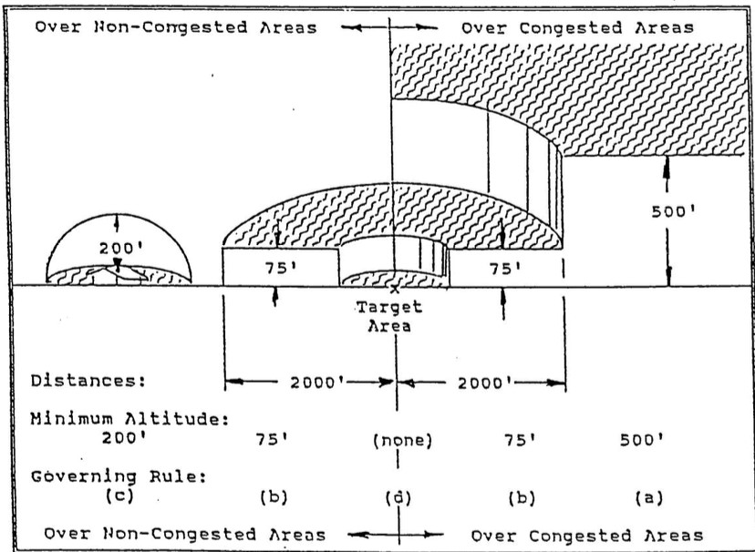

Weather Requirements
Flight operations will be conducted during the period from published Sunrise to Sunset, under Visual Flight Rules (VFR) and weather conditions as specified in 14 CFR part 91 §91.155. Maximum demonstrated surface winds must be 10 knots or less. The decision to fly is the sole responsibility of the PIC and the decision of whether to hold a task is the sole responsibility of the Events Assistant Director, which will result from consultation with appropriate event officials and the FAA Monitor (if available).

Communications Requirements / RECALL
Primarily by the required pilot briefing! Most pilots carry either FM, CB, or aircraft radios and some communication is possible by radio. Pilots will be asked to provide their cell phone number and that of their crew chief at registration. The number should be one that is always operational during the event. While the primary use of the number is for Emergency RECALL, we may also use the number to make contact to resolve flight and scoring issues, follow up on missing markers or loggers, and propane refueling status.

Air Traffic Coordination
A NOTAM will be requested from Lockheed-Martin Information Technology at 877-487-6867 advising air traffic of numerous balloons in the area at varying altitudes on August 8th-10th during the three hours immediately after sunrise and three hours prior to sunset.

Festival Map:

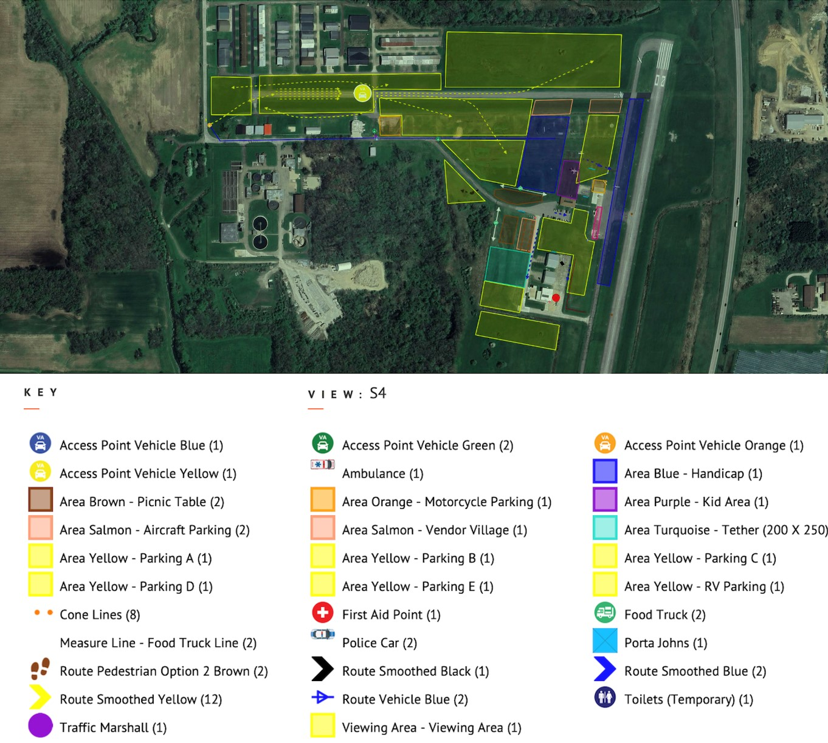

Detroit Sectional

Wadsworth Municipal Airport Launch Site
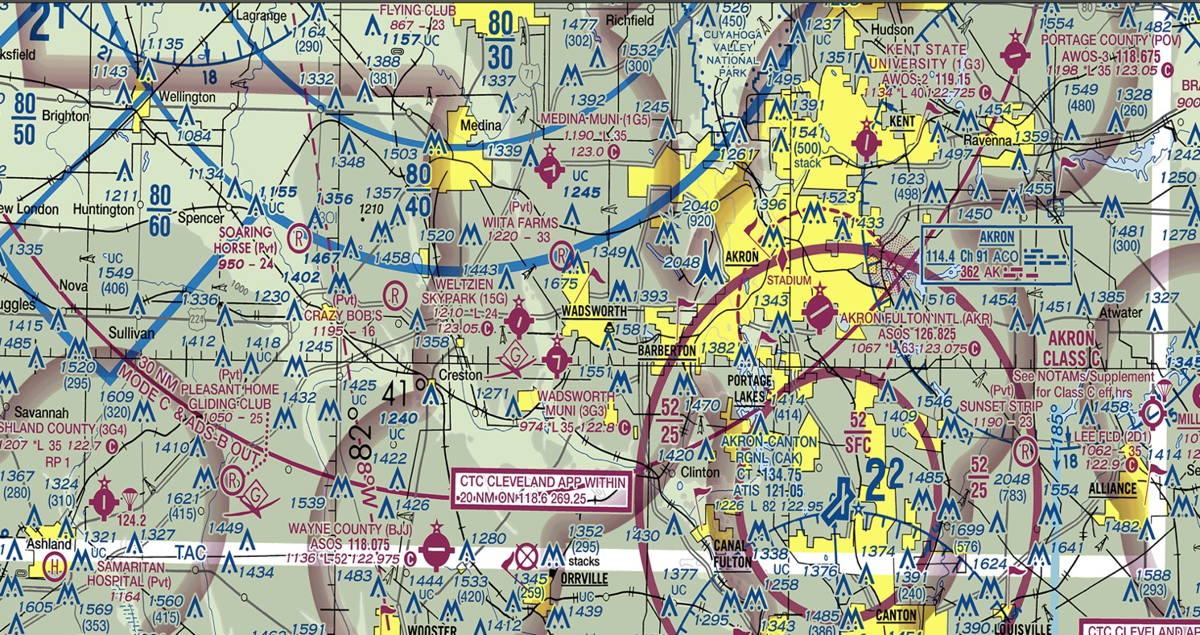

2025 Balloons Over Wadsworth
Tentative Pilot Schedule -
(As of 4/20/2025)

Friday, August 8th
0600 Preparation for Media Flight @ airport
0630 Sunrise
0630-0730 Media Flight launch period
0830 Refueling start time
1430-1630 Balloonist Check-in
1630-Master Briefing, Check-in room
1700-1830 Pilots Dinner
1830-1900 Flight Briefing
1900-1930 Balloon Launch Period-Sponsor Flight
2030 Propane Refueling
2033 Sunset

Saturday, August 9th

0600-0900 Airport Closure
0530 Pilot Briefing @ Hotel
0631 Sunrise
0631-0730 Launch period for Competition flight
0830 Propane Refueling
1600 Balloons Return
1615-1715 Pilot Autograph Session
Helicopter Rides
Tethered Balloon Rides
1730-1830 Balloon Pilot and Crew meal
1830 Pilot Briefing
1900-1930 Balloon Launch Period
2030 Balloons Return
2033 Sunset
2030-2130 Balloon Glow/Fuel Immediately Following

Sunday, August 10th

0530 Pilot Briefing @ Hotel 0632 Sunrise
0632-0730 Launch Period for Competition Flight
0830 Fueling Begins
10:30 Awards Brunch at Hotel

Flight Crew Acknowledgement of Responsibility

Please Print: ___________________ ________________________ _________________________

Pilot Name: ___________________ ________________________ _________________________ First Middle Last

ACKNOWLEDGEMENT OF RESPONSIBILITY AND BRIEFING
Provisions permit crew to be carried during competition but require that the number be kept to a maximum of two (2). Please have all crew sign the Flight Crew Acknowledgement of Responsibility form. Have all your crew sign the enclosed form and maintain this form throughout the weekend. You may be asked to produce this document by an FAA representative. I hereby acknowledge that:
- I have received appropriate training concerning my duties relative to the event; Initials: ________
- I have attended the pilot and crew member briefing before each event; Initials: ________
- I have been designated Event Flight Crew member for the purpose of this event. Initials: ________

RELEASE OF ALL CLAIMS
In consideration of the agreement to permit me to be a designated flight crew member, on behalf of myself, my heirs, successors, executors, administrators, and legal representatives (collectively "I") do hereby release and forever discharge the Inspire Aviation., its Subsidiaries & The City of Wadsworth, financial sponsors of the balloons, race officials and their respective officers, event directors, trustees, agents, members, employees, successors and assigns, and each of them, from any and all claims, demands, damages, actions and causes of action of every name and nature, anticipated or unanticipated, which I may have against any of the aforementioned organizations and persons, which may arise out of or result from or in any manner be connected with the balloon flight or activity in which I participate as a designated flight crew member. Balloon flight or activity includes but is not limited to the preparation, take-off, flight, landing, and boarding, pack-up or travel to or from the take-off or landing areas, including ground transportation thereto. I certify that I am at least 18 years of age, and that I have no medical or mental condition that prevents me from participating in the Ballooning Activities or from executing this Agreement. Further, I understand and acknowledge that Ballooning Activities are hazardous activities and that there is a possibility that those participating could be injured and/or killed while participating. Finally, I understand that I am being permitted to be a designated crew member only on the condition that I grant a full and complete release of any and all claims that may arise against the organizations and persons designated herein as a result of any injuries (including death) or damages that I may suffer as a result of or arising out of the balloon flight or activities. This Agreement was entered into in Ohio and shall be enforced and interpreted under Ohio law. Should any clauses in this Agreement conflict with state law, then only that clause shall be null and void while the remaining clauses shall remain in full force and effect.

IN WITNESS WHEREOF, I hereunto set my hand at Wadsworth, Ohio, this ____ day of May 2025

___________________________________ ________________________________ _____________
PRINTED NAME SIGNATURE Date

___________________________________ ________________________________ _____________
PRINTED NAME SIGNATURE Date
___________________________________ ________________________________ _____________14
Crew Pre-Flight Checklist:
No Smoking around the Balloon. Listen for instructions from pilot, Crew Chief, or another Crew, Don’t Walk on the balloon, Stand Clear of ropes and the fan
Be aware of the balloons movements while inflating.
Be ready to go when the balloon is upright, board carefully. Do not interfere with ropes, tanks, or instruments on board. Feel Free to point out obstacles to the Pilot during flight

Crew Landing Checklist

Still, no smoking around the balloon. Listen for directions from the Pilot, Stow any loose gear securely, use a firm handhold as directed
Bend your knees and keep your joints flexible, not locked.
Be prepared for the balloon to “bounce two or three times” or
Skid before stopping.

Stay in the basket and hold on until instructed to exit. Be respectful of property owners, remember to take your personal belongings with you.

 | Balloons Over Wadsworth Pilots 2025
 | First Name | Last Name | Pilot Type | PIC Hrs. | Last 12 Mo | Pass/Wt. | Media Fl | Dist. to WW | Fiesta/Comp
1 | Paul | Dale | Commercial | 284 | 26 | 149 | N | 33 | Comp
2 | Ben | Leatherman | Private | 162 | 50 | 100 | N |  | Comp
3 | Steve | Mitchell | Commercial | 400 | 37 | 150 | Y | 51 | Comp
4 | Sean | Askrin | Commercial | 3100 | 50 | 2 | Y |  | Comp
5 | James | Mitchell | Commercial | 330 | 20 | 600 | Y |  | Fiesta
6 | Meredith | Bennett | Private | 312 | 35 | 125 | N |  | Comp
7 | Darrin | Fall | Private | 180 | 14 | 1 | N |  | Comp
8 | Shannon | Rote | Commercial | 690 | 20 | 200 | Y | 6 | Comp
9 | Jim | Cusic | Commercial | 588 | 30 | 250 | N |  | Comp
10 | Michael | O'Brien | Private | 170 | 20 | 1 lite | Y |  | Comp
11 | Brad | Burdue | Commercial | 1110 | 60 | 400 | N |  | Fiesta
12 | Shawn | Raya | Commercial | 2398 | 38 | 100 | Y |  | Comp
13 | Joey | Strutz | Private | 215 | 40 | 100 | N |  | Comp
14 | Janet | Lutkus | Commercial | 985 | 36 | 150 | Y | 15 | Comp
15 | Travis | Gauthier | Private | 275 | 20 | 400 | N |  | Comp
16 | Garrett | Gerwig | Private | 66 | 25 | 299 | Y | 36 | Fiesta
17 | Larry | Coan | Commercial | 625 | 40 | 150 | N |  | Comp
18 | Chris | Smart | Commercial | 2047 | 65 | 650 | Y |  | Fiesta
19 | Jake | Tyler | Commercial | 500 | 30 | N/A | Y |  | Fiesta
20 | Eric | Eaton | Commercial | 432 | 26 | 0 | Y |  | Fiesta
21 | Rick | Kohut | Commercial | 800 | 28 | 459 | Y |  | Fiesta
22 | Ryan | Duff | Commercial | 200 | 40 | 0 | Y |  | Comp
23 | Eric | Reeder | Private | 211 | 32 | 250 | N |  | Comp
24 | Pat | Karl | Private | 163 | 12 | 300 | N |  | Fiesta
25 | Preston | Lama | RC |  |  |  | Y |  | Fiesta
26 | Jim | Cusic | RC |  |  |  | N |  | Fiesta
27 | Late Entry | Corporate

